**Lesson07 Azure Blob Prosperities and metadata**

**Notes: -**

**1-you can set meta-data for each blob either on the Azure Portal or by using VS2019**

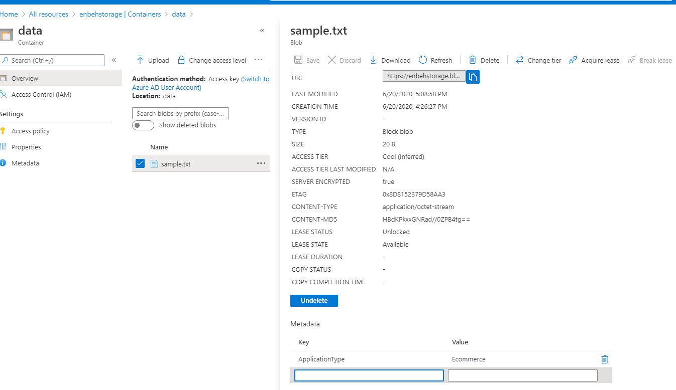

**2-on VS 2019 we set the following code to get meta-data and set meta-data of the azure blob**

**using Azure.Storage.Blobs;**

**using Azure.Storage.Blobs.Models;**

**using System;**

**using System.Collections.Generic;**

**using System.IO;**

**using System.Threading.Tasks;**

**namespace blobproperties{**

**class Program{**

**static string connstring = "DefaultEndpointsProtocol=https;AccountName=enbehstorage;AccountKey=pgSgc8psXmSTgwdIE+fsozrDkirh1YfbKcJWgn9fKRAdo54Dq4ugJ7PPENrK1sFrsAMZY7C3z8dq1U+hAZM9wA==;EndpointSuffix=core.windows.net";**

**static string containerName = "data";**

**static string filename = "sample.txt";**

**static async Task Main(string[] args){**

**GetProperties();**

**SetMetadata();**

**GetMetadata();**

**Console.WriteLine("Operation complete");**

**Console.ReadKey();}**

**static void GetProperties(){**

**//it will make instance of the azure storage blob client**

**BlobServiceClient blobServiceClient = new BlobServiceClient(connstring);**

**//it will make instance of the azure stroage blob container client**

**BlobContainerClient containerClient = blobServiceClient.GetBlobContainerClient(containerName);**

**//it will make instnace of blob client by access the blob Name**

**BlobClient blob = containerClient.GetBlobClient(filename);**

**//it will get the blob properities**

**BlobProperties properties=blob.GetProperties();**

**//it will get the access tier and content length of blob**

**Console.WriteLine("The Access tier of the blob is {0}",properties.AccessTier);**

**Console.WriteLine("The Content Length of the blob is {0}", properties.ContentLength);}**

**static void GetMetadata(){**

**//it will make instance of the azure storage blob client**

**BlobServiceClient blobServiceClient = new BlobServiceClient(connstring);**

**//it will make instance of the azure stroage blob container client**

**BlobContainerClient containerClient = blobServiceClient.GetBlobContainerClient(containerName);**

**//it will make instnace of blob client by access the blob Name**

**BlobClient blob = containerClient.GetBlobClient(filename);**

**//it will get the blob properities**

**BlobProperties properties = blob.GetProperties();**

**//it will get all meta data of the azure blob**

**foreach(var metadata in properties.Metadata){**

**Console.WriteLine(metadata.Key.ToString());**

**Console.WriteLine(metadata.Value.ToString());}}**

**static void SetMetadata(){**

**//it will set meta-data key and value pairs**

**string p_key = "ApplicationType";**

**string p_value = "Ecommerce";**

**//it will make instance of the azure storage blob client**

**BlobServiceClient blobServiceClient = new BlobServiceClient(connstring);**

**//it will make instance of the azure stroage blob container client**

**BlobContainerClient containerClient = blobServiceClient.GetBlobContainerClient(containerName);**

**//it will make instnace of blob client by access the blob Name**

**BlobClient blob = containerClient.GetBlobClient(filename);**

**//it will set meta-data of the blob into azure contaienr**

**IDictionary<string, string> obj = new Dictionary<string, string>();**

**obj.Add(p_key, p_value);**

**blob.SetMetadata(obj);}}}**